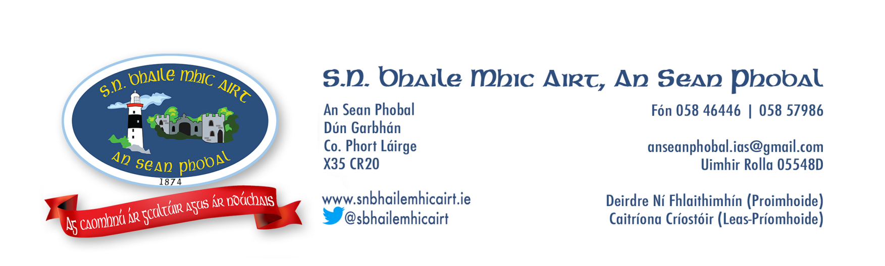

**Bord Bainistíochta S.N. Bhaile Mhic Airt 2023 - 2027**

* Cathaoirleach*Chairperson***:** Cabríní de Barra
* Cisteoir *Treasurer:* Michael Hogan
* Rúnaí *Secretary*: Deirdre Ní Fhlaithimhín
* Ionadaí múinteora *Teacher representative*: Liam Ó Lonáin
* Iondaí tuismitheora (Máthair) *Parent rep (Mother)* Olivia Fennell
* Iondaí tuismitheora (Athair) *Parent rep (Father)*: Séamus Ó Lonáin
* Ionadaí pobail *Community rep*: Brian de Barra
* Ionadaí pobail *Community rep*: Martín Ó Coffaigh