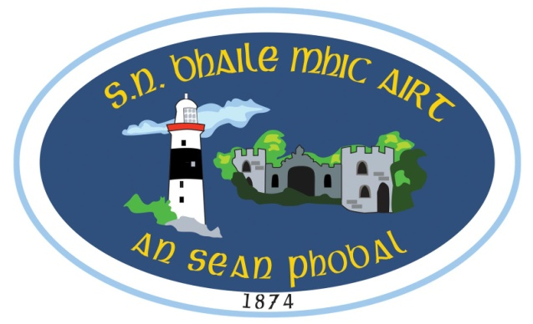

**anseanphobal.ias@gmail.com - 058 46446**

**Foirm Iontrála 2023/2024**

|  |  |
| --- | --- |
| **Ainm an pháiste** Name of Child  **Uimhir PPS** PPS number  **Seoladh baile & eircód** Home address & Eircode  **Dáta breithe** Date of Birth  **Reiligiún an pháiste** Religion of the child  **Dáta & áit gur bháistíodh an pháiste** Date & place of Baptism |  |
| **Ainm an máthair** Name of mother (nó caomhnóir baineann/ or Female Guardian)  **Seoladh baile** Home address  **Slí beatha** Occupation  **Uimhir baile** Home no.  **Uimhir guthán póca** Mobile no.  **Uimhir fón obair** Work No. |  |
| **Ainm an athair** Name of father(nó caomhnóir fireann/ or Male guardian)  **Seoladh baile** Home address  **Slí beatha** Occupation  **Uimhir baile** Home no.  **Uimhir guthán póca** Mobile no.  **Uimhir fón obair** Work No. |  |

|  |
| --- |
| **Cén duine atá ceadaithe do pháiste a bhailiú ón scoil?**  Who is permitted to collect your child from school?   1. **Ainm** name   **Seoladh** address  **_ Fón** Phone  **2. Ainm** name  **Seoladh** address  **Fón** Phone    **3. Ainm** name  **Seoladh** address  **Fón** Phone |

|  |  |
| --- | --- |
| **1. Fadhbanna sláinte /Ailléirge** Health Problems/Allergies  **2. Ainm an dochtúra** Name of Dctr  **3. Uimhir an dochtúra** No. of Dctr  **4. An dtógann do pháiste leigheas go rialta?** Does your child take medicine on a regular basis?  **5. Má thógann inis dúinn cad a thógann said agus cé chomh minic is a thógann said é.** If so state type and frequency of medicine taken.  **6.** **An gcaithfidh do pháiste leigheas a thógaint fad’s atá sé/sí ar scoil.** Does your child have to take medicine during school hours? |  |
| **Má thógann caithfidh tú ráiteas scríofa a thabhairt don príomhoide ag rá gurb é an pháiste atá freagrach dá leigheas féin agus nach mbeidh an múinteoir ranga freagrach as é a thabhairt don pháiste nó d’aon eachtraí a d’fhéadfadh tarlú dá bharr.**  If so you are required to give a written statement to the Principal stating that the child is responsible for his/her own medicine and that the class teacher will not be held responsible for the administration of the medicine or for any consequences that may arise. | |

|  |
| --- |
| **Muna mbíonn tuismitheoirí ar fáil, cén duine a chuirfidh an scoil glaoch air/uirthi?**  If parents are unavailable who can the school contact in the case of an emergency?  **1**. **Ainm**  **Seoladh**  **Fón:**  **. 2.** **Ainm**  **Seoladh**  **Fón:**  **1. An bhfuil cead ag 1. do pháiste a bhailiú ón scoil má tá sé/sí tinn?** Tá □ Níl **□**  Does contact 1. have permission to collect your child from school in the case of illness  **2. An bhfuil cead ag 2. do pháiste a bhailiú ón scoil má tá sé/sí tinn?** Tá □ Níl **□**  Does contact 2. have permission to collect your child from school in the case of illness  **3. An bhfuil riachtanais** **speisialta oideachais nó mí-chumas ag do pháiste?**  Does your child have special educational needs or a disability? Tá □ Níl **□**  **(Más ‘ea cuir in iúl don príomhoide i scríbhinn le do thoil.**  If yes, please inform the principal in writing. )  **4. An bhfuil cead ag do pháiste freastal ar ranganna ‘Bí Sábháilte’**  Does your child have permission to attend the Stay Safe Programme? Tá □ Níl **□**    **5. I gcás citron ar scoil no tinneas an bhfuil cead do pháiste a thabhairt**  **díreach go dtí’n t-ospidéal?**  In the case of serious accident or illness do you give permission to take your child straight to hospital? Tá □ Níl **□**  **6. An bhfuil cead ag an scoil griangrafanna a ghlacadh de do pháiste nó**  **guth do pháiste a thaifead?**  Does the school have permission to take photographs or voice recordings of my child? Tá □ Níl □  **7. An bhfuil aon cúrsaí dlí ag baint le do pháiste?**  Does any legal order, under family law, exist that the school should know about? Tá □ Níl □  **8.** **An nglacann tú le Cód Iompair na scoile agus na rialacha atá ann?** Glacaim / Ní ghlacaim  Do you accept the school’s behavioural policy and the rules within? I accept / I don’t accept  **9. An bhfuil cóip den teastas breithe curtha leis an fhoirm seo?**  Have you included a copy of the child’s birth certificate? Tá □ Níl □ |

**Siniú__________________________________ Dáta______________________**