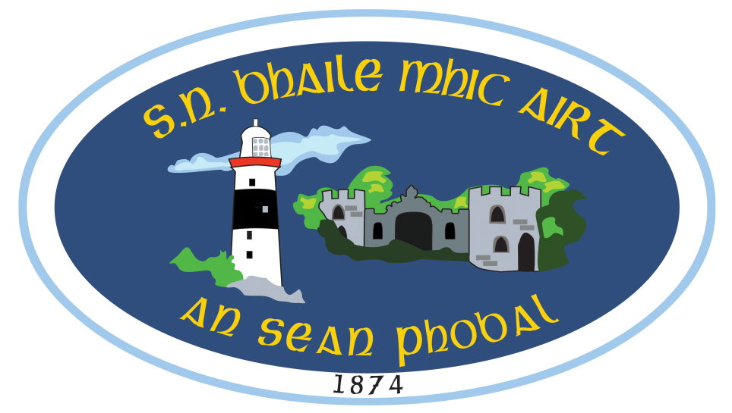

Polasaí na Meáin Shóisialta / *Social Media Policy*

***Introduction:***

*The Board of Management at S.N. Bhaile Mhic Airt acknowledges the increasing use of social media sites for purposes that are connected to school life. The Board of Management also recognises the numerous benefits and opportunities which a social media presence offers, not only in terms of keeping the school community up to date with what is happening in the school, but also in terms of attracting potential enrolment. Having a school website is an essential part of this and all parents and/or interested parties must specifically visit the school website to regularly receive information on items such as school policies, contact details and upcoming events. By having a social media page (Twitter, Instagram or Facebook) the school is feeding school information and new notices directly and quickly into the personal news feeds of parents and the wider school community. This policy aims to encourage the safe use of all social media by the school, its staff and parents/guardians and in doing so safeguard the school’s reputation and/or reputation of staff and all who use it. This policy aims to outline acceptable use for all schools social media use by staff, parents and members of the wider community.*

***Definitions***

*Social media refers to the means of interactions among people in which they create, share, and exchange information and ideas in virtual communities and networks. Social Media: refers to all social networking sites. These sites include, but are not limited to: Facebook, Snapchat, Whatsapp, Twitter, LinkedIn, Google+, KIK, Instagram, SMS, YouTube and includes emails and mobile devices.*

**Scope of the Policy**

The policy covers the use of all social media platforms used by teachers, staff, parents and guardians and the wider community where said platforms may be connected in any way to the running of and/or activities within the school. All those connected to the school should bear in mind that the information they share through the use of social media platforms, even in a private setting, are subject to copyright, data protection, freedom of information and defamation laws and policy.

**General Terms of Use**

The terms of use apply to the use of all social media platforms by all those who have a connection to the school. This includes but is not limited to, public facing applications such as open discussion forums and internally facing uses such as project blogs regardless of whether they are hosted on the school network or not.  Where applications allow for the posting of messages on line, users must be mindful of the laws that may be applicable to such postings.

**Aims and Objectives**

*Aims:*

1. *To build and grow a strong reputation for the school as an active, caring and positive environment for all children.*
2. *To build and grow a strong reputation for the school as an active Gaeltacht school where the Irish language is lived, loved and preserved, on a daily basis.*
3. *To promote the school to new parents and families with a view to increasing enrolment in the school.*
4. *To facilitate communication and networking opportunities between parents especially new or prospective parents*
5. *To maintain contact with past parents and past pupils*

*Objectives:*

1. *To publicise the many positive and varied school and classroom activities that take place on a regular basis.*
2. *To share these events with parents and other interested parties (these can include the local community, other school communities, other interested parties locally and nationally)*
3. *To advertise any upcoming events such as fundraisers and/or religious celebrations.*
4. *To highlight school and/or pupil achievements*

**Rights and responsibilities**

*A community can only function effectively when all members afford and treat each other with respect. Members of the school community - parents, staff and members of the local community - are expected to give respect to each other, and to the good name and reputation of the school. However the potential for direct and/or indirect damage to be caused to others and/or to the school through inappropriate use of social media is very real. The Board of Management of S.N. Bhaile Mhic Airt expects people’s online behavior to reflect the same standards of honestly, respect and consideration that a person uses face to face and to be in accordance with the school ethos.*

***Users must consider the following when online:***

* *Think before they post*
* *Respect the rights, privacy and confidentiality of others*
* *Demonstrate appropriate personal and professional boundries and behaviours*
* *Ensure their online behaviour reflects the same stands of honesty, respect and consideration that a person uses when communicating face to face*
* *Not publish any content which may result in criminal action and/or civil actions for defamation, discrimination, breaches of copyright, data protection or other claims for damages.*
* *Not publish content that could amount to bullying, harassment, discrimination or victimization.*
* *Not to air grievances (contact the classroom teacher and/or principal directly for any and all grievances)*
* *Not send or post discriminatory, harassing, negative comments, threatening messages or images that may cause harm to any member of the school community.*
* *Not to forwarding or ‘Like’ material that is likely to cause offence or hurt to a third party.*
* *Not to promote financial interests, commercial ventures or for personal campaigns.*
* *Not to discuss or give advice on any school related matters, teaching methods, school policies, staff, pupils or parents.*
* *Not to publish any content that may have a negative impact on the school’s and/or the staff’s reputation.*
* *Not to publish the school logo without the express written permission of the Board of Management.*

***Specific terms of use for staff on the use of social media***

* *No member of staff should interact with any pupil in the school on social networking sites*
* *No member of staff should interact with any ex-pupil in the school on social networking sites who is under the age of 18.*
* *Children under the age of 13 are not allowed open a twitter account.*
* *Staff should not identify themselves as a representative of the school*

***Child protection guidance***

*If any user receives a disclosure that an adults using a social networking site in an inappropriate manner as detailed above they should:*

* *Report the disclosure to the Designated Liaison Person (The Principal)*
* *The disclosure should be recorded by the Designated Liaison Person in line with the child protection policy, and Tusla should be contacted for guidance.*
* *Procedure as advised by Tusla will be followed, and the necessary authorities contacted.*

***Breach of Policy.***

*Breach of this policy may have disciplinary repercussions, including but not limited to the following:*

* *Immediate removal*

*Reviewed by the Board of Management of S.N. Bhaile Mhic Airt, An Sean Phobal*

*To be reviewed annually.*

*Siniú: ________________________________ Cathaoirleach _____________ Dáta*

*__________________________________ Príomhoide ______________ Dáta*