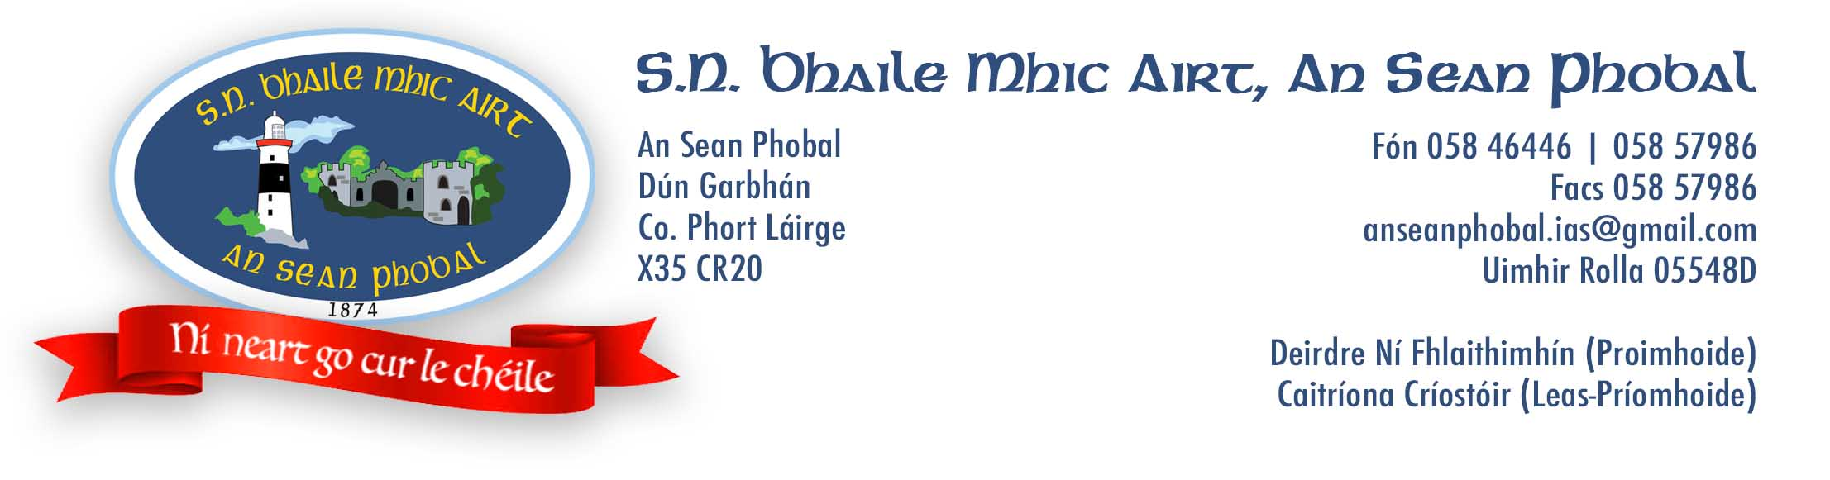

**Bunaíodh Scoil Náisiúnta Bhaile Mhic Airt sa Sean Phobal sa bhliain 1874. Scoil Ghaeltachta a bhí ann i gcónaí agus fós inniu is í an Ghaeilge príomhtheanga teagaisc & cumarsáide na scoile.**

**Is scoil ghníomhach agus áthasach í an scoil seo ina bhfuil cultúr traidisiúnta Gaeltacht na nDéise fite-fuaite i ngnáth-shaol na bpáistí, idir dhramaíocht, cheol thraidisiúnta agus rince ina measc. Tá ard-chaighdeán bainte amach againn sa Mhata agus sa Litearthacht le blianta beaga anuas agus tá stádas oifigiúil mar scoil Ghaeltachta, mar atá leagtha amach ag an Roinn Oideachas agus Scileanna, bainte amach againn ó 2018.  Tá tradisiúin láidir le feiscint sa scoil sa spóirt, ach go háirithe sa pheil gaelach agus san iomáint.**

**Is scoil Chaitliceach í an scoil seo faoi choimirce an tEaspag Deoise Phort Láirge agus na Leasa Móire, An tEaspag Alphonsis Ó Culleanán. Tá dearcadh Críostaíochta ag baint leis na scoil.  Freastalaíonn na páistí ar aifreann go rialta agus glacann said leis na sacraimintí. É sin ráite, glactar le páistí le aon creideamh agus fiú páistí gan creidimh.**

S.N. Bhaile Mhic Airt was founded in An Sean Phobal in the year 1874. It has always been a Gaeltacht school and today Irish continues to be the main language of instruction and communication. We are an active and happy school in which the culture and traditions of the Déise Gaeltacht are intertwined in the everyday lives of the children including drama, traditional music and singing. We have achieved a high standard in Maths and Literacy over the last number of years and in 2018 we achieved official Gaeltacht status, as laid out by the Department of Education and skills.  There is a strong tradition of sport to be seen in the school also, especially Gaelic football and hurling. It is a Catholic school under the patronage of the Bishop of the diocese of Waterford and Lismore, Bishop Alfonsus Cullinan. There is a Christian outlook in all we do in the school, with the children attending mass regularly and receiving the sacraments. That said, we accept children of all religions and even those without.

**Is mise le meas**

**Deirdre Ní Fhlaithimhín,  Príomhoide**